***DAY – 5 (15/04/2024)***

***EMPLOYEE UPDATE NAME OUTPUT***

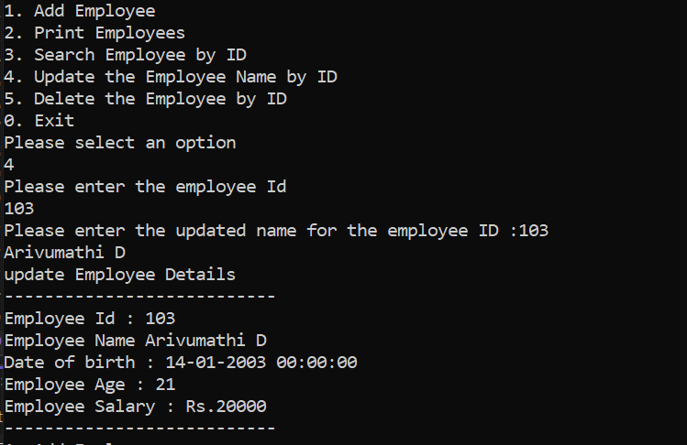

***DELETE EMPLOYEE***

